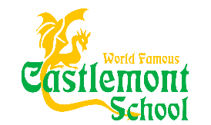
Pre-Order your Castlemont Sweatshirts and T-shirts Today!
 | X-Small | Small | Medium | Large | X-Large
Youth Green Hooded Sweatshirt $30
Youth Yellow Hooded Sweatshirt
$30
Youth Green T-shirt $15
Youth Yellow T-shirt $15

Student Name_____________________________________
Teacher Name and Room #___________________________
Total amount enclosed $___________
Please return form by September 16th
Please make checks payable to Castlemont HSC
Questions about apparel please contact Maren Buchanan at marenbuchanan@gmail.com

